TM2 - Introduction to SQL

Hands-on Assignments

Assignment 1

Question:
Determine the Structure of DEPT Table and its Contents.

Query:

DESC DEPT_WIPRO;

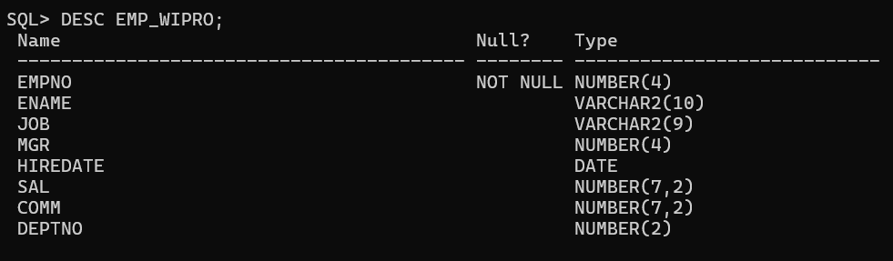
SELECT * FROM DEPT_WIPRO;

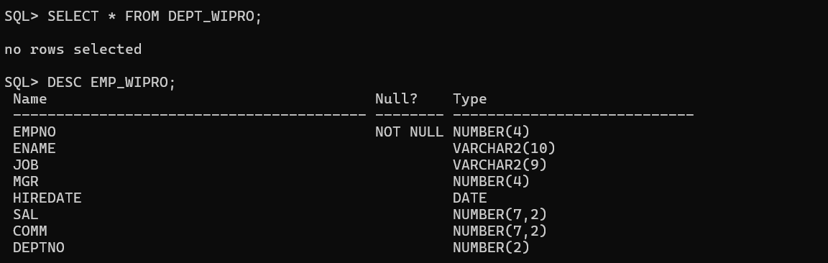

Assignment 2
Question:
Determine the Structure of EMP Table and its Contents.
DESC EMP_WIPRO;
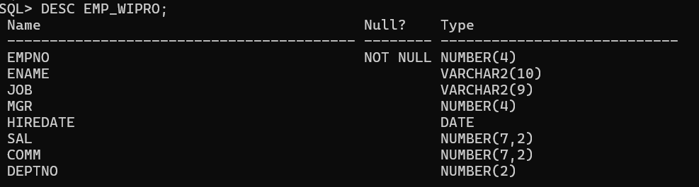

SELECT * FROM EMP_WIPRO;

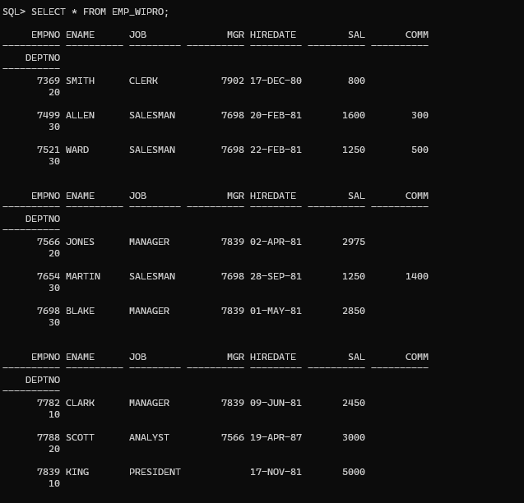
Assignment 3
Question: Display the Ename and Deptno from Emp table whose Empno is 7788.

